- NETWORK TOPOLOGIES ASSIGNMENT

- Bus Topology
A bus topology connects all devices to one main communication cable called the backbone cable. The devices share this cable for sending and receiving data. Terminators are placed at both ends of the backbone to stop signals from reflecting back through the cable.
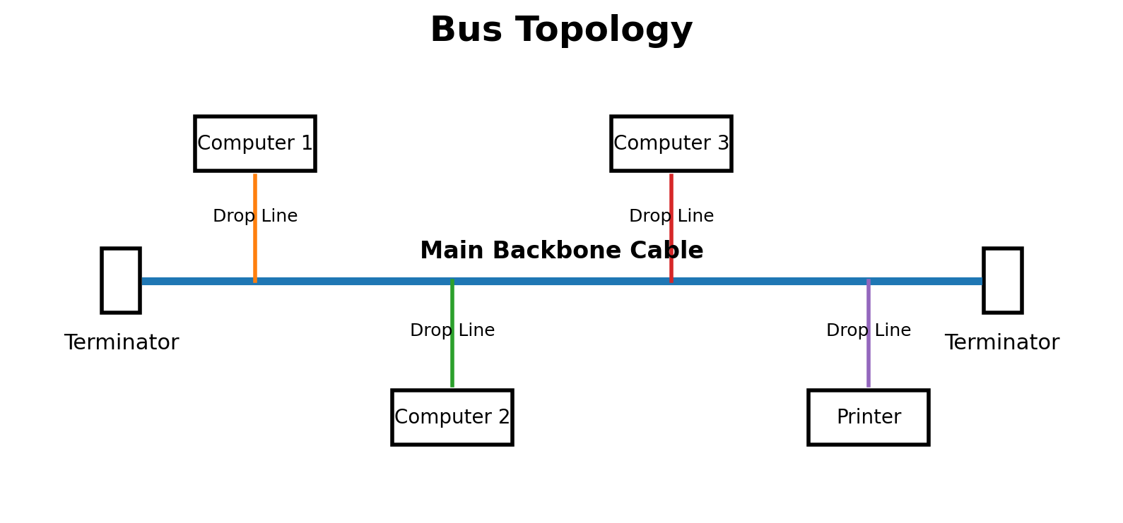
Figure 1: Bus topology with key components labeled.
Real-world example: Older Ethernet networks using coaxial cable, such as 10BASE2, used a bus-style arrangement where several computers shared the same main cable.

2. Star Topology in Cisco Packet Tracer
A simple star topology can be created using one Cisco 2960 switch and four PCs. Each PC is connected directly to the central switch using a Copper Straight-Through cable. The PCs are named WhatsApp, Zomato, Spotify and Flipkart.
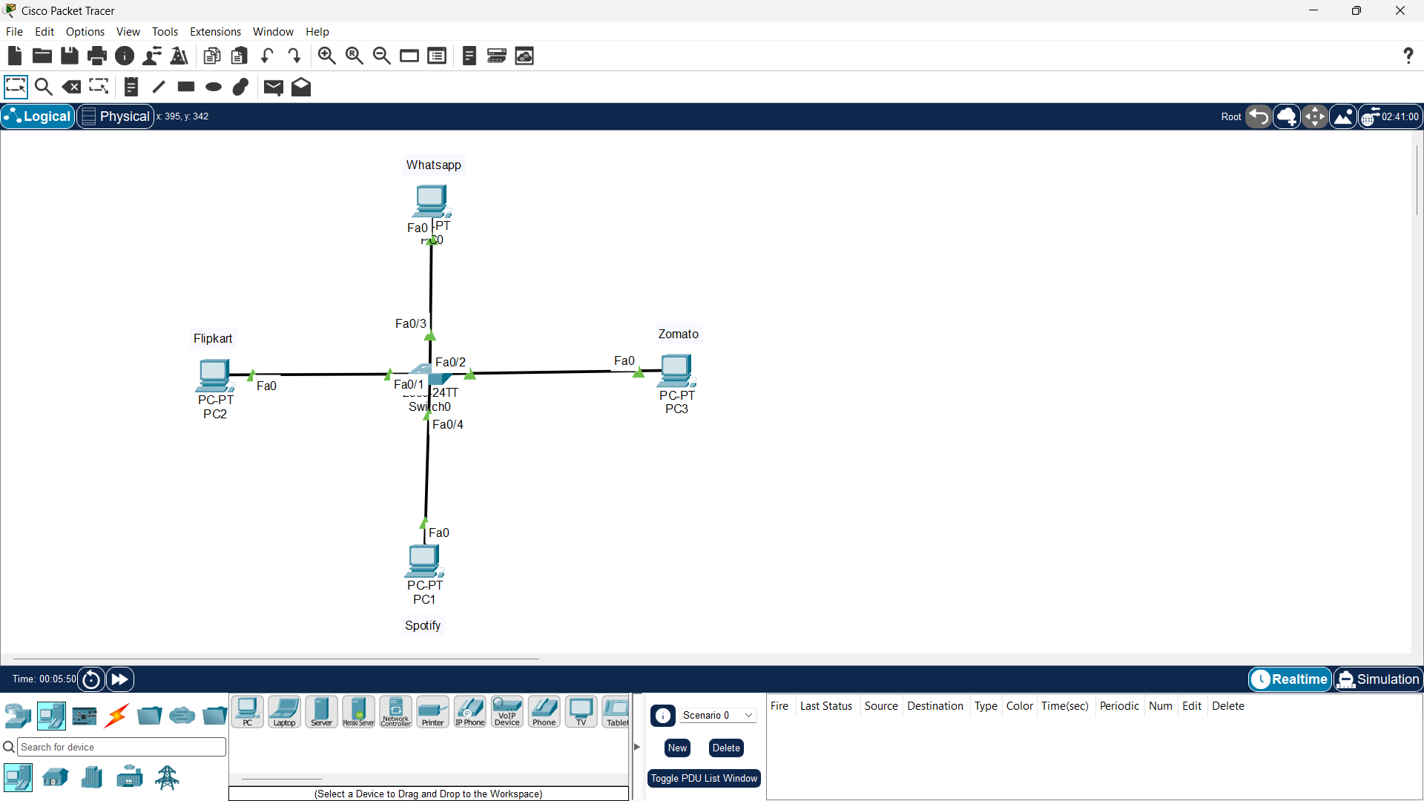

3. Ring Topology
In a ring topology, every device is connected to two neighboring devices, forming a closed loop. Data travels from one device to the next around the ring until it reaches the destination. The arrows in the diagram show one possible clockwise direction of data flow.
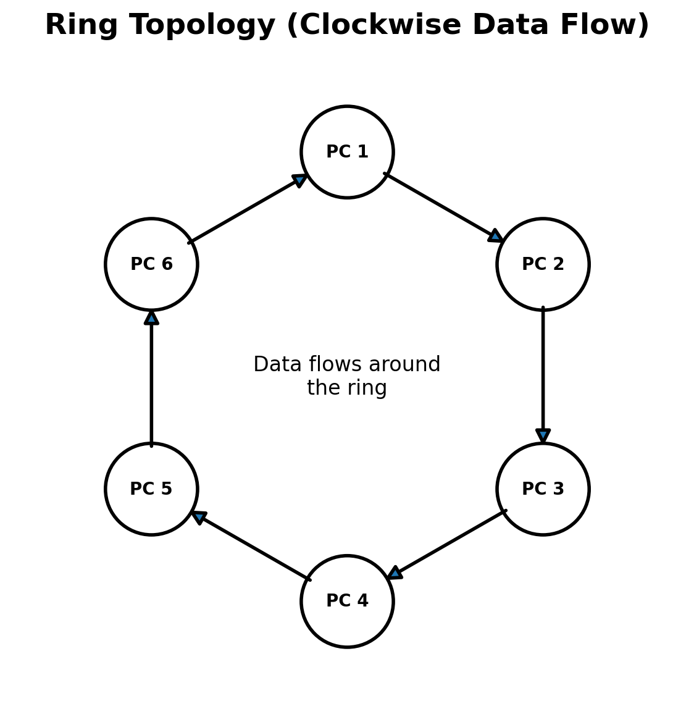
Figure 3: Ring topology with arrows showing data flow.

4. Comparison of Mesh and Star Topologies
Topology | Advantages (2) | Disadvantages (2) | Simple Use
Mesh | 1. Very reliable because multiple paths are available.  2. Failure of one link usually does not stop the whole network. | 1. Requires many cables and ports.  2. Expensive and difficult to install/manage. | Critical networks where high reliability is needed.
Star | 1. Easy to install, manage and troubleshoot.  2. Failure of one PC/cable does not affect the other PCs. | 1. If the central switch fails, the whole network is affected.  2. Requires more cable than a bus topology. | Home, school, college and office LANs.

Conclusion
Different network topologies are suitable for different needs. Bus topology is simple but has a shared backbone, star topology is common and easy to manage, ring topology sends data around a loop, and mesh topology provides high reliability by using multiple connections.

